Assignment 16.
- What is Table type?
- A Table Type is a Data Dictionary (DDIC) object that defines the structure and functions of an internal table.
- Components of Table Type
- When creating in SE11 → Table Type:
- 1.Line Type
- Structure or DB table
- 2.Table Category
- 1.Standard table
- 2.Sorted table
- 3.Hashed table
- 4.Index Table
- 5.Not Specified
- 3.Key Definition
- Primary key fields
- 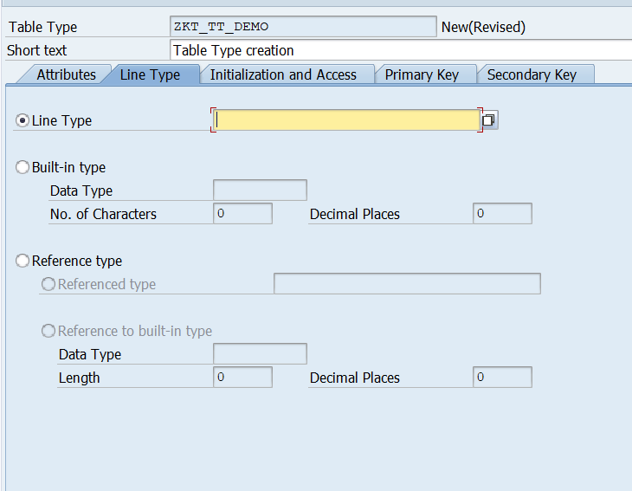
- the line type is the data structure of one row of the internal table.
- Line Type:
- Here we can specify Structure name, Database table name, Data element name
- Built-in Type: Here we directly define a basic ABAP data type.
- Data type (CHAR / NUMC / INT…)
- Length
- Decimal
- Eg: Data type = CHAR
- Length = 10
- Reference Type:
- Used when the table should store references instead of actual data
- a) Referenced Type → reference to class/interface/type
- b) Reference to Built-in Type → reference to basic type
- Used in OOP ABAP programs.
- Example:
- Structure: ZSTR_STUDENT
- Fields: ID, NAME, AGE
- Table Type: ZTT_STUDENT
- Line Type: ZSTR_STUDENT
- Meaning: Internal table of student records.
- 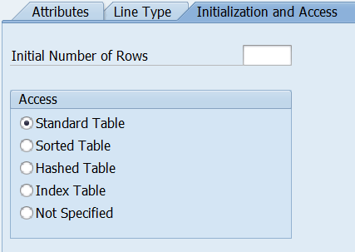
- Initial Number of Rows:
- This field specifies how many rows SAP should initially reserve memory for when the internal table is created.
- Purpose:
- It improves performance by avoiding repeated memory allocation when many records are expected.
- Eg: If Initial Number of Rows = 1000
- SAP allocates space for 1000 entries at table creation.
- Access Type (Table Category)
- This defines how records are stored and accessed in the internal table.
- 1. Standard Table:
- A standard table stores records in insertion order and allows access by index or key.
- Linear Search
- 2. Sorted Table:
- A sorted table keeps records automatically sorted according to the key.
- Binary Search
- 3.Hashed Table:
- A hashed table stores records using a hash algorithm for key-based access.
- Fast Search
- 4. Index Table:
- Index table is a generic category representing tables that can be accessed by index.
- 5. Not Specified:
- No table category defined in DDIC.
- Programmer defines category in ABAP.
- Table Type creation
- SE11-> Table Type(Radio Button)-> Provide name-> Create-> Enter Short text-> save.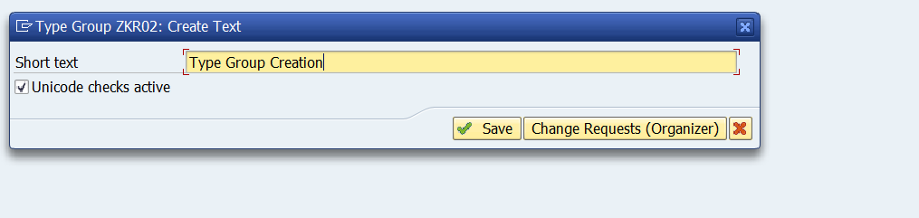
- Write Source code:
- 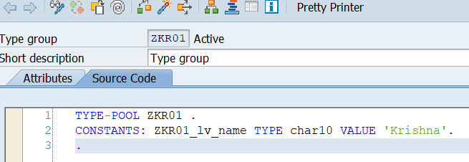
- What is type pool?
- A type pool is a container that stores reusable data types and constants, which can be accessed in ABAP programs using the TYPE-POOLS statement.
- How Type Pool is Created
- Transaction: SE11
- Type Group.
- Steps:
- SE11
- Choose Type Group
- Enter name (Z…)
- Create
- Define TYPES / CONSTANTS
- Activate

- Difference between Type pool and Table type
- Difference: Type Pool vs Table Type
- Type Pool
- Collection of many types
- Program-level usage
- TYPE-POOLS needed
- Table Type
- One internal table type
- DDIC object
- Direct TYPE usage

- What is Type Group?
- A type group is a Data Dictionary object (technical name of a type pool) that stores globally reusable type definitions and constants used in ABAP programs via the TYPE-POOLS statement.

